## Imagen que contiene Icono Descripción generada automáticamenteUNIVERSIDAD AUTONOMA DE COAHUILA CENTRO DE IDIOMAS US



**1ST TEST**

LEVEL 9 KIDS

**STUDENT´S NAME: DATE: TEACHER´S NAME: WRITTEN GRADE ORAL GRADE**

**VoVcaobcaublaurlyary**

# Look at the pictures. Write the words.

downtown gas station platform highway

|  |  |
| --- | --- |
|  |  |
| 1 | 2 |
|  |  |
| 3 | 4 |

**/ 8 points**

1. **Choose words from the box to complete the sentences.**

flight leave passengers passport suitcases ticket

* 1. My to London is at one o’clock.
  2. I have two for my clothes.
  3. I bought a at the travel agency.
  4. My has a very old photo of me in it.
  5. There are a lot of on this flight. The plane is full.
  6. Don’t forget your keys before you the house.

**/ 12 points**

**Grammar**

# Read the sentences and choose A, B, or C.

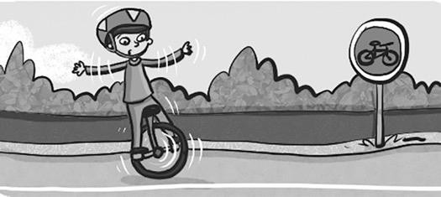

* 1. Have you … a unicycle?

A ☐ ever ridden B ☐ ever ride C ☐ rode

* 1. They have … on a plane before now.

A ☐ never fly B ☐ never flown C ☐ ever fly

* 1. Has she … her passport at home?

A ☐ ever leave B ☐ leave C ☐ ever left

* 1. I have … to Paris.

A ☐ ever be B ☐ ever been C ☐ never been

* 1. He has … late at school.

A ☐ never arrive B ☐ never arrived C ☐ ever arrived

**Writing**

**/10 points**

**6. Read the questions and write your own answers. Freddy** Where do you live?

## You 1

**Freddy** How long have you lived there?

## You 2

**Freddy** What places can you visit there?

## You 3

**Freddy** How do you get to your school?

## You 4

**Freddy** Have you ever lived in another area?

**You** 5

**/ 10 points**

**Reading**

# 5 Read the interview and choose A, B, or C.

Katy: How long have you lived in Manchester? Jay: I’ve lived here 1 … a year.

Katy: What do you like about this city?

Jay: It’s really modern, but it has a great history, too. There’s 2 … an airport here for more than 80 years and there’s a museum that has been here 3 … 1867!

Katy: Have you ever been to the museum? Jay: No, I’ve 4 … been there, but I want to!

Katy: Is there anything you don’t like about the city?

Jay: Well, it’s very busy and there are 5 … downtown all the time. Especially on the weekends!

Katy: Will you live in a village in the country in the future? Jay: No, I don’t want to move! I love it here!

People of Manchester

1. A ☐ since B ☐ for C ☐ ago
2. A ☐ for B ☐ since C ☐ been
3. A ☐ since B ☐ in C ☐ for
4. A ☐ ever B ☐ never C ☐ haven’t
5. A ☐ airport B ☐ crowds C ☐ gas station

**/ 5 points**

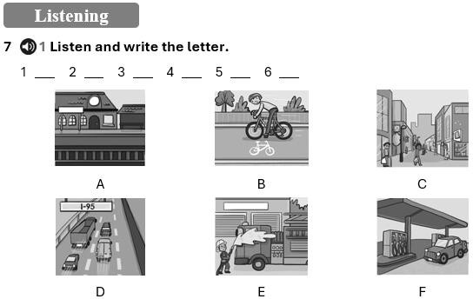

**/ 5 points**

**TOTAL POINTS 50**